Project Design Phase-Il

Technology Stack (Architecture & Stack)

|  |  |
| --- | --- |
| **Date** | **24 October 2022** |
| **Team ID** | **PNT2022TMID20647** |
| **Project Name** | **Deep Learning Fundus Image Analysis for Early Detection of Diabetic Retinopathy** |
| **Maximum marks** | **4 marks** |

Technical Architecture:

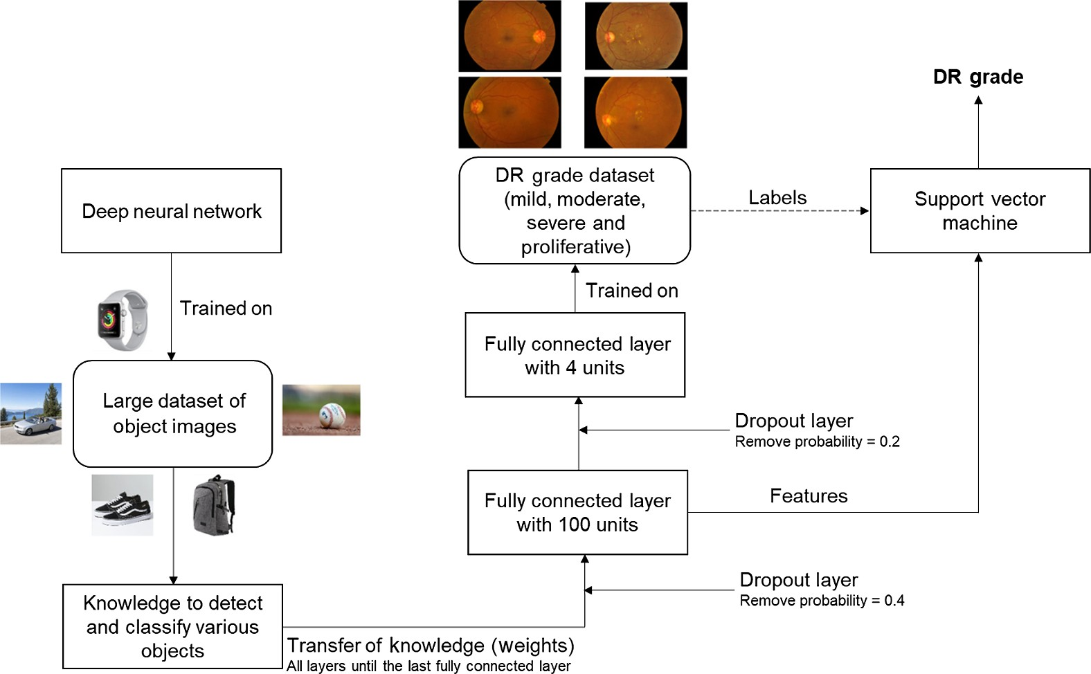

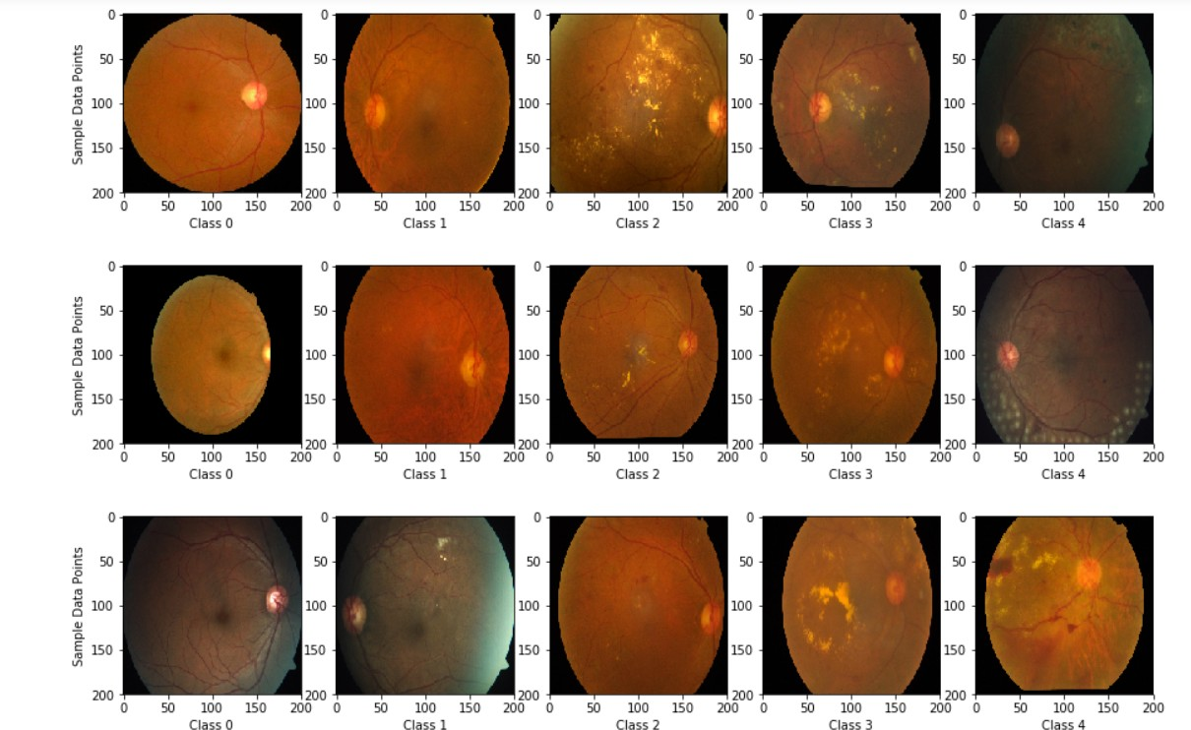

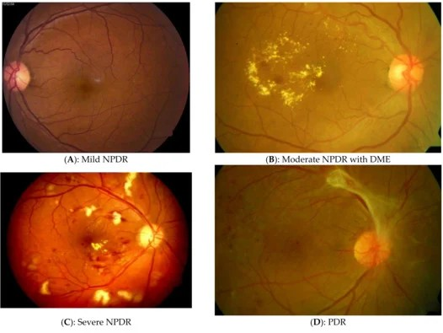

Table-1: Components & Technologies:

|  |  |  |  |
| --- | --- | --- | --- |
| S.NO | Component | Description | Technology |
| 1 | User Interface | How user interacts with application e.g. Web UI, Mobile App, Chatbot etc. | HTML, CSS, JavaScript / Angular Js / React Js etc. |
| 2 | Application Logic-1 | Logic for a process in the application | Java/Python |
| 3 | Application Logic-2 | Logic for a process in the application | IBM Watson STT service |
| 4 | Application Logic-3 | Logic for a process in the application | IBM Watson Assistant |
| 5 | Database | Data Type, Conﬁgurations etc. | MySQL, NoSQL, etc. |
| 6 | Cloud Database | Database Service on Cloud | IBM DB2, IBM Cloudant etc. |
| 7 | File Storage | File storage requirements | IBM Block Storage or Other Storage Service or Local Filesystem |
| 8 | External API-1 | Purpose of External API used in the application | IBM Weather API, etc. |
| 9 | External API-2 | Purpose of External API used in the application | Aadhar API, etc |
| 10 | Machine Learning Model | Purpose of Machine Learning Model | Object Recognition Model, etc. |
| 11 | Infrastructure (Server/Cloud) | Application Deployment on Local System | Local, Cloud Foundry, Kubernetes, etc. |

Table-2: Application Characteristics:

|  |  |  |  |
| --- | --- | --- | --- |
| S.No | Characteristics | Description | Technology |
| 1 | Open-Source Frameworks | List the open-source frameworks used | Technology of Opensource framework |
| 2 | Security Implementations | List all the security/ access controls implemented, use of ﬁrewalls etc. | e.g. SHA-256, Encryptions, IAM Controls, OWASP etc. |
| 3 | Scalable Architecture | Justify the scalability of architecture (3-tier, Technology used  Micro-services) | Technology used |
| 4 | Availability | Justify the availability of application (e.g. use of load balancers, distributed servers etc.) | Technology used |
| 5 | Performance | Design consideration for the performance of the application (number of requests per sec, use of Cache, use of CDN's) etc. | Technology used |